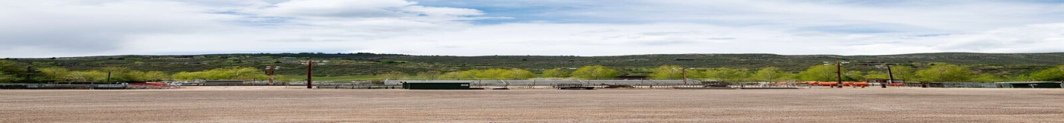

Snowmass Rodeo grounds slated to get bigger, not smaller, with Town Park revamp

Planners currently working toward 60% complete design
With Snowmass Town Park’s eventual improvement, the rodeo grounds should expand on Tuesday, May 24, 2022. (Kelsey Brunner/The Aspen Times)
Like perennial flowers that bud every spring, the plans for a redesign of the Snowmass Rodeo grounds at Town Park have once again popped up in town discussions.
Designers are currently working on bringing the plans for a Town Park revamp from the 30% complete stage to the 60% complete stage, and planners informed the council earlier this month that phase one of the project may be subject to some scope-cutting, since the cost estimate was about $1 million over budget.
Also this spring, the Roaring Fork Valley Horse Council made its own safety-oriented recommendations and presented them to the Parks, Open Space, Trails and Recreation board.

The council is a nonprofit organization that focuses on equestrian resources throughout the valley. Some of its members are spectators and competitors at the Snowmass Rodeo, but it is not affiliated with the nonprofit Snowmass Western Heritage Association that organizes the rodeo.
The Horse Council’s primary recommendations focused on the size and layout of the arena and the rodeo grounds. They emphasized the importance of safety, accommodating all of the existing amenities at the rodeo and fostering a connection between spectators and the competitors who represent the town’s Western heritage.
Horse Council board member Karin Reid Offield said that the council’s vision for the rodeo includes a larger footprint for the grounds — “that they don’t try to make it smaller, they give it room to grow.”
The grounds actually are slated to get larger, according to Andy Worline, the director of parks, recreation and trails for the town of Snowmass Village.
The current rodeo grounds, including the “vending area, spectator areas, stands, loading areas, pens, arena, ticketing” and other facilities, cover about 82,000 square feet, Worline wrote in an email. That figure doesn’t include parking.
The proposed plans for the new rodeo grounds “including all those same things” cover just over 90,000 square feet, Worline wrote. (Again, the number doesn’t include parking.) The plans don’t incorporate a designated warm-up area for horses.
The Snowmass Western Heritage Association and the Roaring Fork Valley Horse Council are two separate, independent entities. But many of the recommendations that the Horse Council made this spring were similar to those that the town had already discussed with the Snowmass Western Heritage Association, Worline said in a phone call.
“A lot of the discussions that the Horse Council had were suggestions and issues that the rodeo (board) brought up during the master planning,” Worline said. “We worked through with the rodeo team to make those recommendations right, not that we can do everything.”
The Snowmass Village Town Council approved the master plan in March after ironing out some misunderstandings with the rodeo board. The rodeo board withdrew its support in a letter in February but conversations among the board, Town Council and Town Park planners revealed that the blip was the result of mixed messages, not conflicting interests.
Snowmass Western Heritage Association board member Markey Butler said the board is satisfied with the current plans.
“The rodeo (board) is fine with the plan, we’ve had input into the plan,” Butler said. “Darce (Vold) … and Jim Snyder are the two that really understand the rodeo and the inner workings of the rodeo. They’ve worked really hard to make sure that what we need for the rodeo to continue to move forward is in the design, which it is.”

