1/18/2026

To: The Roaring Fork Outdoor Coalition (RFOC), Design Workshop, and the Community Advisory Group, regarding important issues that were mentioned in our 1/14/2026 meeting, but time restrains curtailed discussion.

From: Roaring Fork Valley Horse Council, Holly McLain Communication Chair and Karin Reid Offield RFVHC President

Underserved Trail User Groups
Hikers and horseback riders represent a comparatively under-served group within many recreational trail systems. In some regions, mountain biking has become the most prevalent form of trail use, shaping how trails are designed, managed, and prioritized.
Equestrian participation involves substantial time, space, and financial commitment. Horses require land, daily care, regular exercise, and ongoing veterinary support, which naturally limits the number of trail riders. Bikes on the other hand can be parked in a garage with minimal maintenance.
Did you know that there are only three BLM hiker and horseback rider trails in the Roaring Fork Valley:
(1) The Sutey Ranch,
(2) The Crown Jewel Horse Trails, which leads into
(3) the Pitkin County Glassier Equestrian Trail. (BLM and Pitkin County have provided good equestrian parking to access these trails)

There are over 300 miles of single track, mountain bike trails in the Roaring Fork Valley.

Reports of fast-moving bikes meeting other trail users often end in accidents. The presence of fast-moving mountain bikes can limit the availability of trails that are considered safe for hikers and horseback riders.
Parking Access
Adequate parking access is essential for all trail users. Trucks and horse trailers require larger, more specialized parking spaces than standard passenger vehicles, which can limit access, if parking areas are designed primarily for cars.
At many trailheads, parking areas fill quickly with smaller vehicles, leaving insufficient space for horse trailers and resulting in limited or unavailable access for equestrian users. Addressing parking design and the management of the parking lots should address all of different user group’s needs, ensuring equitable trail access for all.

Ranches and Open Space Lands
Ranchers and open space landowners play a vital role in maintaining working landscapes that support both wildlife habitat and traditional land uses. The presence of horses and cattle helps sustain open, undeveloped lands that provide important corridors and refuge for wildlife.

Outfitters and ranching operations also support recreational opportunities centered around equestrian use and hiking. We owe thanks to ranchers, outfitters and open space landowners for keeping the trails open and cleared by keeping horses and cattle on these lands, thereby providing a lifeline to the wildlife. Remember, outfitters and ranchers sustain and maintain our trails for the slower moving equestrian recreationalists and hikers. We cannot afford to lose them.

Unchecked Development, Water Use and Strained Resources
Across many counties nationwide, communities are experiencing increased development pressure driven by the need for housing and to help generation tax revenue. However, little thought is given to the existing residents, their quality of life and to the environment. Water aquifers are being overwhelmed and depleted. *Water wells in Missouri Heights, above the valley floor are failing. Traffic congestion is causing bottlenecks everywhere. (Example: Starting on I-70, driving from Parachute to Aspen on Hwy 82, traffic is bumper to bumper from 5 AM to 11 AM every day, summer and winter) * Water sustainability - https://www.keepmohrural.com/water-sustainability

High-Intensity Use vs Quiet Trail Recreation
There is a reason why mountain bike/e bike mechanized use is prohibited in designated Wilderness under federal law. Biker’s speed, volume, and technology alter a sense of solitude, disturbing quiet recreation values.

Trail Damage and High Use Impacts
Soil erosion and rutting caused by tire shear (especially during braking, cornering and climbing) dislodges soil. Wet soft soils are particularly vulnerable; bikes can cut deep ruts that channel water and accelerate erosion. Switchbacks and steep grades suffer most damage. Essentially bikes can turn a flat single-track trail into a banked roller coaster track, making it difficult for hikers and horses to negotiate comfortably and safely. Walking on a sloping hill trail is never pleasant. In alpine and high prairie/desert environments, natural recovery from soil disturbance occurs slowly. Once erosion is established, trail repair often requires active management rather than natural regeneration and the recovery is slow. (Red Hill, Carbondale, CO is a perfect example – According to the Bureau of Land Management (BLM), Red Hill receives approximately 70,000 visitors per year. This level of use contributes to year-round trail erosion and wear from both local and visitor traffic, creating maintenance demands that exceed the capacity of the Red Hill Council, the Town of Carbondale, and the BLM to address fully.

Wildlife Impacts from Bicycle Use
Wildlife disturbance can increase when animals encounter fast-moving trail users, particularly in areas where bicycles travel at higher speeds. Sudden encounters may trigger heightened stress responses, contribute to nest abandonment, and disrupt normal predator–prey behavior.

Slower-moving trail users, such as hikers and horseback riders, typically create more predictable movement patterns. This allows wildlife additional time to detect and respond to human presence, often reducing startle reactions. Going slow gives us the opportunity to notice beautiful wildflowers, bird’s songs and flights, and we often stop to watch the calm passage of our wildlife partners, who relate to horses as just another prey animal. We need to preserve and protect safe places for the wildlife, the hikers and the horseback riders, who are walking, not racing on trails.
Preserving areas where trail use remains calm and predictable can benefit wildlife while supporting hikers and equestrians who rely on steady footing and lower-speed trail environments. Trail planning and management that account for speed and wildlife sensitivity can help balance recreation with habitat protection.
E Bikes Don’t Belong on Single Track Trails
E-bikes are motor-assisted vehicles, and their use raises distinct management considerations on narrow single-track trails. Compared to non-motorized bicycles, e-bikes produce higher torque and faster acceleration, which can increase soil displacement, particularly during climbing and braking.
E-bikes are also heavier than traditional mountain bikes, intensifying trail wear over time, especially on steep or narrow sections. On single-track trails, limited width reduces opportunities for safe passing or avoidance during sudden encounters, and the additional weight and speed of e-bikes causes stopping problems.
On narrow single-track, there is often no escape room when sudden encounters happen. E bikes are harder to stop when encountering other trail users.
No Margin for Error: Equine Safety on Multi-Use Trails
Signage and education is key for understanding the risk for horses on trails with fast moving mountain /e bikes. Often there is no escape room for horseback riders to avoid bike collisions on single track trails. Here are two signs which will help everyone understand what to do when meeting horses on multi-use trails:
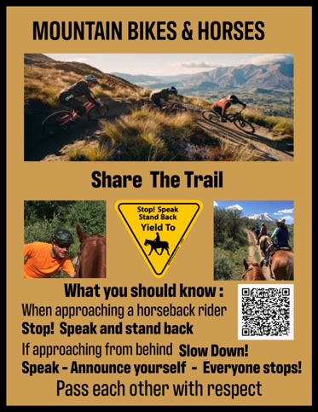 | 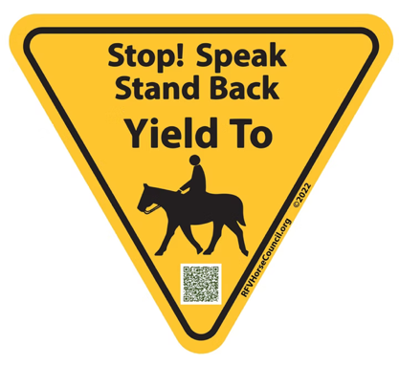

Inclusive Outreach to Another Underserved Community
The Latinos are an important part of the broader community and is not always fully reflected in trail communication and outreach efforts. Providing trailhead signage in Spanish can help ensure that information about trail use, safety, and stewardship is accessible to a wider audience.
In addition, school-based programs offer an opportunity to engage Spanish-speaking children at an early age, fostering an understanding of land stewardship, conservation, and shared responsibility for natural resources. Inclusive outreach supports both community connection and long-term care of public lands. Below is Spanish language signage for all trail users to “Leave No Trace”, and Trail Safe Passing Plan (TSPP) Stop! Speak and Stand back:
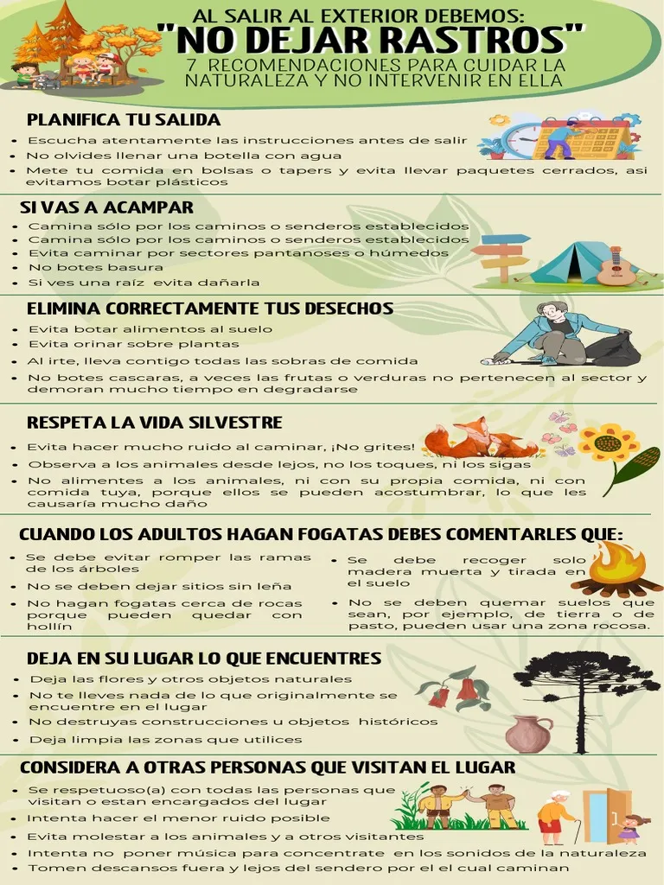 | 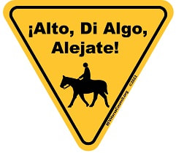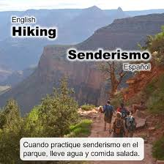
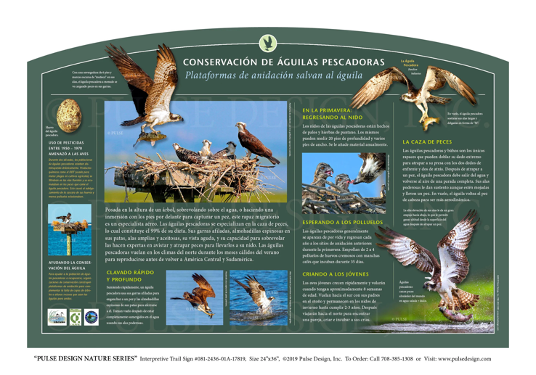 | Many trailheads now offer bilingual signs. Sign on left in English, while sign on right in Spanish.  Trail rules: No Hunting (No Cazar), No Trespassing (No Pasar), Private Property (Propiedad Privada), Beware of bears ( Quidado con los osos)
Spanish sign for wildlife identification above.

Consistency of Signage

BLM, Pitkin County Open Space and Trails, and Rio Grande Trail signage all differ in presentation and messaging. It is imperative that the information for trail etiquette, safety, and speed requirements are the same. Each governmental entity wants their particular signs with their colors, designs and messaging. This causes confusion for trail users, especially on the Rio Grande Trail. The State of Colorado should attempt to provide the same guidelines and protocols for different trail managers signage.

Nationally recognized: Trail Safe Passing Plan signage:

https://www.rfvhorsecouncil.org/trails-safe-passing-plan

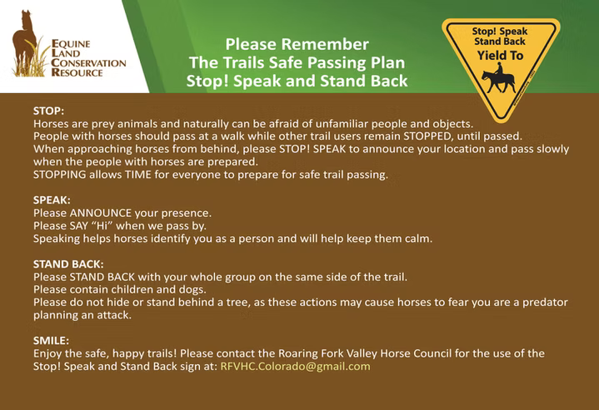

The TSPP signs are being used in 15 states across the nation, with more states adopting this plan and signage as their own. Yielding to horseback riders is the International Regulation for universal trail signage around the world.
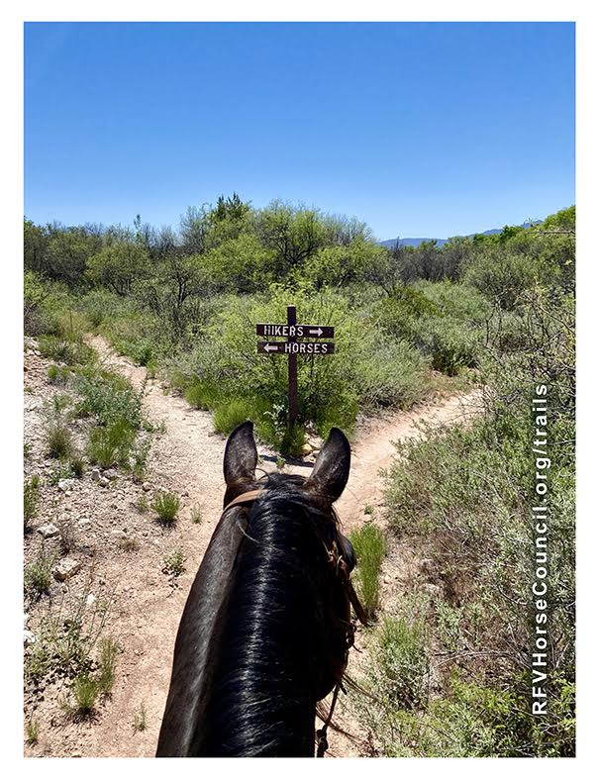 | All of us here today, most likely bike, fish, hike and many ride horses or mules.  This Trail Safe Passing Plan (TSPP) Stop! Speak and Stand Back can be used by all – hikers, dog walkers, fishermen, bicyclists, birders, and even motor vehicle drivers. We believe that everyone can and should be prepared when encountering people with horses on the trails.  It is important to know what to do first and what needs to be done after stopping on the trail to keep everyone safe and having fun.
For more information contact us at rfvhc.colorado@gmail.com or call Holly at 970-948-2151

